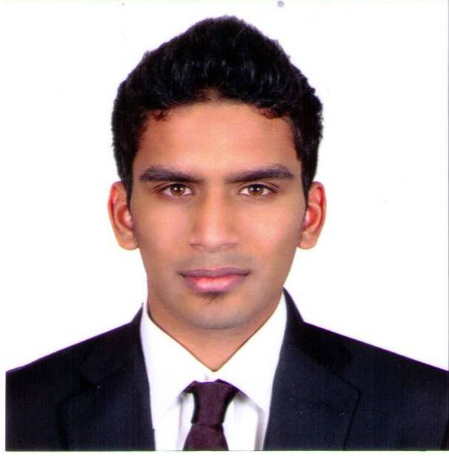
REMSTON P. MARTIS
Goregaon (E), Mumbai
remstonmartis@gmail.com
+91-9967605747

OBJECTIVE
An enthusiastic Chemical Engineering graduate, seeking to use my leadership and technical skills towards the growth of the organization.

EDUCATION

Bachelor of Science in Chemical Engineering
Purdue University, West Lafayette, Indiana, U.S.A. – May 2015

INDUSTRIAL EXPERIENCE / UNIVERSITY PROJECTS

Commodore MEP – Abu Dhabi, U.A.E. June 2016 – August 2017
Electrical Engineer
- Working on High, Low and Extra Low voltage systems including Building Management System.
- Able to understand and prepare SLD, Load Schedule and technical drawings.

Chemical Engineering Senior Design – Purdue University, U.S.A. January 2015 – May 2015
Team Leader
- Simulated and optimized process to handle cryogenic gases and hydrocarbons for large scale energy generation and storage using Aspen software.
- Performed equipment sizing, economic cost evaluation, capital investment and failure mode analysis to test feasibility, environmental impact and safety associated with using chemicals like carbon dioxide, methanol, etc.
- Conducted HAZOP, developed PFDs, P&ID, heat and material balances and proposed plant layout.

Jotun Paints - Abu Dhabi, U.A.E. June 2012 – July 2012
Process Control, Production, Quality Control
- Tested the quality of manufactured paint in the lab.
- Operation of batch, semi batch and CSTRs.
- Recorded data, preparation time, and de-bottlenecking areas to improve production efficiency.

Chem-E-Car Club - Purdue University, U.S.A. August 2013 – May 2015
Active Member & Treasurer
- Placed 5th in Regionals and qualified for Nationals in 2013 and 2014.
- Worked on annual budgeting and designing of model.

EPICS Lab (Chemical Sensing Initiative) - Purdue University, U.S.A. January 2012 – December 2012
Active Member & Project Partner Liaison
- Designed prototype and calibrated chemical sensors.
- Integrated Arduino with GPS to display real location and time.

SKILLS
Aspen, Labview, Matlab, AutoCAD
Understanding of P&ID, PFDs
Hazop Analysis, FMEA as part of Process Safety
C++ Programming, Microsoft Office (Word, Excel and PowerPoint)

INTERESTS
Enjoy playing sport and music.
Currently reading ‘The Wealth of Nations’.
Studying for the FE exam.

PERSONAL DATA
Date of Birth : 12 December 1992
Nationality : Indian
Marital Status : Single
Driver’s License : Holding a valid driving license.

