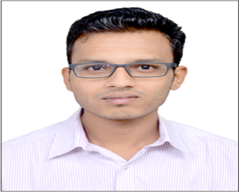

**Mr. Snehal Fulzele**

B.Tech - Chemical

**Phone:**  +918087741833

**Email:** [sgfulzele29@gmail.com](mailto:sgfulzele29@gmail.com)

**CAREER OBJECTIVE**

Seeking career in Process engineering or in Operations where I can use my skills and knowledge and wish to grow in every aspect by brightening my skills and problem solving methodologies into limelight in achieving organizational goals.

**ACADEMIC PROFILE**

|  |  |  |  |
| --- | --- | --- | --- |
| **Year** | **Qualification** | **Institute** | **Percentage/CGPA** |
| 2016 | Bachelors of Technology | Dr. Babasaheb Ambedkar Technological University, Lonere | 7.50 |
| 2011 | XII | St. Frances De Sale College, Nagpur | 60.67 |
| 2009 | X | St. John's High School, Nagpur | 73.84 |

**PROFESSIONAL EXPERIENCE**

Company Name – **I G Petrochemical ltd, Taloja, Navi Mumbai**

1st July 2016 – Present

Designation – Shift Engineer (Operations)

Role Description:

* Responsible for smooth, incident free plant operations, achieve consistent yield and quality.
* Responsible for carrying all activities with safe norms.
* Responsible for getting general maintenance activities done with service dept
* Responsible batch time cycle.

**INTERNSHIP**

1. **OIL AND NATURAL GAS Co. Ltd (ONGC)**

30 days winter internship at ONGC Mumbai in Dec 2014 – Jan 2015

* Studied and analyzed various oil drilling techniques and safety aspects in plants with general overview and working.

1. **RASHTRIYA CHEMICAL & FERTILIZER Ltd (RCF Ltd)**

30 days summer internship at RCF Mumbai in June – July 2015.

* Undertook project on optimization of OBR in Water Treatment Plant.
* Analyzed various production plant with general overview and working.

**SKILLS**

* Technical: Programming language known:- C++, C & learning ASPEN
* Others:- Leader, Opportunist, Adventurous and believe in team work

**STRENGTH**

* Quick learner
* Hard working
* Good spokesperson
* Can adjust in any environment
* Good understanding

**EXTRA-CURRICULAR ACTIVITIES AND AWARDS**

* 1st place in University Football League.
* Won two belts in Karate.

**WORKPLACE DRIVER EVALUATION**

* Manage to build good team relationships.
* Ability to take stand in bringing new ideas and faster decision taking ability.
* The exceptional problem solving ability. Prefer to consider new and better ways to do things.
* Responsive towards work related activities.

**PERSONAL DETAILS**

Date of Birth : 29/11/1993

Sex : Male

Nationality : Indian

Languages Known : English, Hindi and Marathi

Present Address : Suryodaya CHS Building, C-6, 203, Sector 10, Kalamboli, Navi Mumbai, Maharashtra, India.

Permanent Address : Plot No. 672 A, Model Town, Kamptee Road, Nagpur, Maharashtra, India.

**DECLARATION**

I hereby declare that the above mentioned information is correct up to my knowledge and I bear the responsibility for the correctness of the above-mentioned particulars.

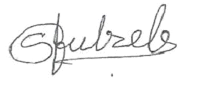

SNEHAL FULZELE